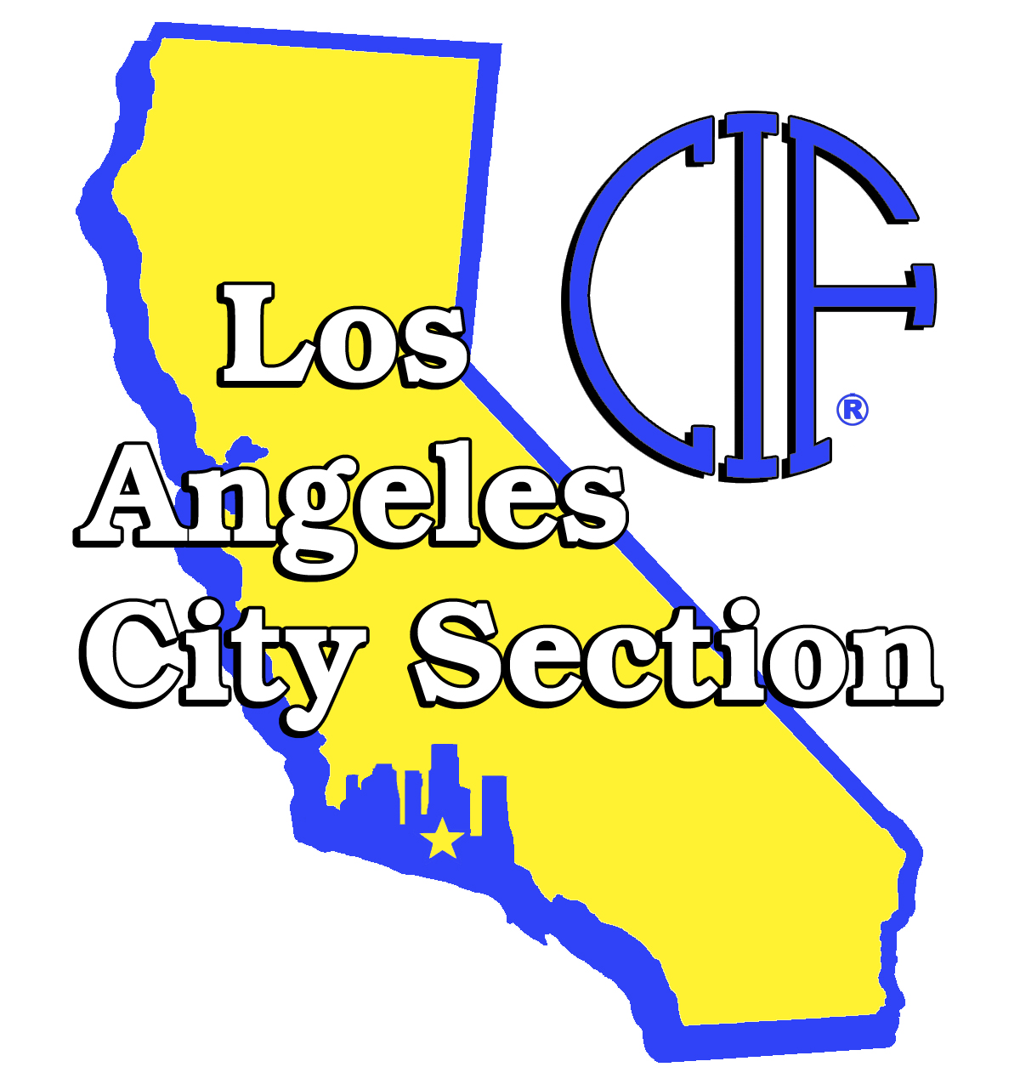
2011 FOOTBALL ALIGNMENT
COASTAL REGION

COLISEUM MARINE WESTERN
Crenshaw (DI) Banning (DI) Fairfax (DI)
Dorsey (DI) Carson (DI) Hamilton (DI)
Fremont (DII) Gardena (DI) Palisades Charter (DI)
Locke(DI) Narbonne (DI) University (DII)
Manual Arts (DII) San Pedro (DI) Venice (DI)
West Adams (DI) Washington Prep (DII) Westchester (DI)
Division I Auto playoff berth
2 2 2

EAST REGION

EASTERN NORTHERN SOUTHERN
Bell (DII) Eagle Rock (DII) Belmont (DII)
Garfield (DI) Franklin (DI) Bernstein (DII)
Huntington Park (DII) Lincoln (DII) Contreras (DII)
Jordan (DI) Marshall (DII) Hollywood (DII)
Roosevelt (DI) Roybal (DII) Jefferson (DII)
South East (DII) Wilson (DII) Los Angeles (DII)
South Gate (DII) Torres (DII) Santee (DII)
Division I Auto playoff berth
1 0 0

VALLEY REGION

EAST VALLEY VALLEY MISSION WEST VALLEY
Arleta (DI) Canoga Park (DII) Birmingham (DI)
Grant (DII) Kennedy (DI) Chatsworth (DI)
Monroe (DII) Panorama (DI) Cleveland(DII)
North Hollywood (DII) Reseda (DI) El Camino Real (DI)
Polytechnic (DI) San Fernando (DII) Granada Hills (DII)
Sun Valley (DII) Sylmar (DI) Taft (DI)
Verdugo Hills (DII) Van Nuys (DII)
Division I Auto playoff berth
1 DI 2 DI 2 DI

SMALL SCHOOL DIVISIONS
DIVISION III – 11 MAN EIGHT MAN FOOTBALL
Animo South LA Charter Animo Jackie Robinson
Annenberg Charter Central City Value
Fredrick Douglass Charter Community Harvest
Fulton College Prep Discovery Prep
Sherman Oaks CES East Valley
View Park Charter Ivy Academia

Associate – Freelance
Bright Star Charter
Los Angeles City Section
2011-12 Football Division Alignment

Division I (28)
Banning
Crenshaw
Carson
Arleta
Birmingham
Chatsworth
Dorsey
El Camino Real
Fairfax
Franklin
Gardena
Garfield
Hamilton
Jordan
Kennedy
Locke
Narbonne
Palisades
Panorama
Poly
Reseda
Roosevelt
San Pedro
Sylmar
Taft
Venice
West Adams Prep
Westchester

Division II (31)
Bell
Belmont
Bernstein
Canoga Park
Cleveland
Contreras
Eagle Rock
Esteban Torres
Fremont
Granada Hills
Grant
Hollywood
Huntington Park
Jefferson
Lincoln
Los Angeles
Manual Arts
Marshall
Monroe
North Hollywood
Roybal
San Fernando
Santee
South East
South Gate
Sun Valley
University
Van Nuys
Verdugo Hills
Washington
Wilson
Division III Small Schools (6)
Animo South LA Charter
Wallis Annenberg Charter
Frederick Douglass Charter
Fulton College Prep
Sherman Oaks CES
View Park Prep Charter

8 Man Division (7)
Animo J. Robinson Charter
Central City Value
Community Harvest Charter
Discovery Prep Charter
East Valley
Ivy Academia Charter

Associate (1)
Bright Star Charter

